**Experiment - 2**

**Aim: Identify the Problem, PEAS/PAGE description and Problem Formulation**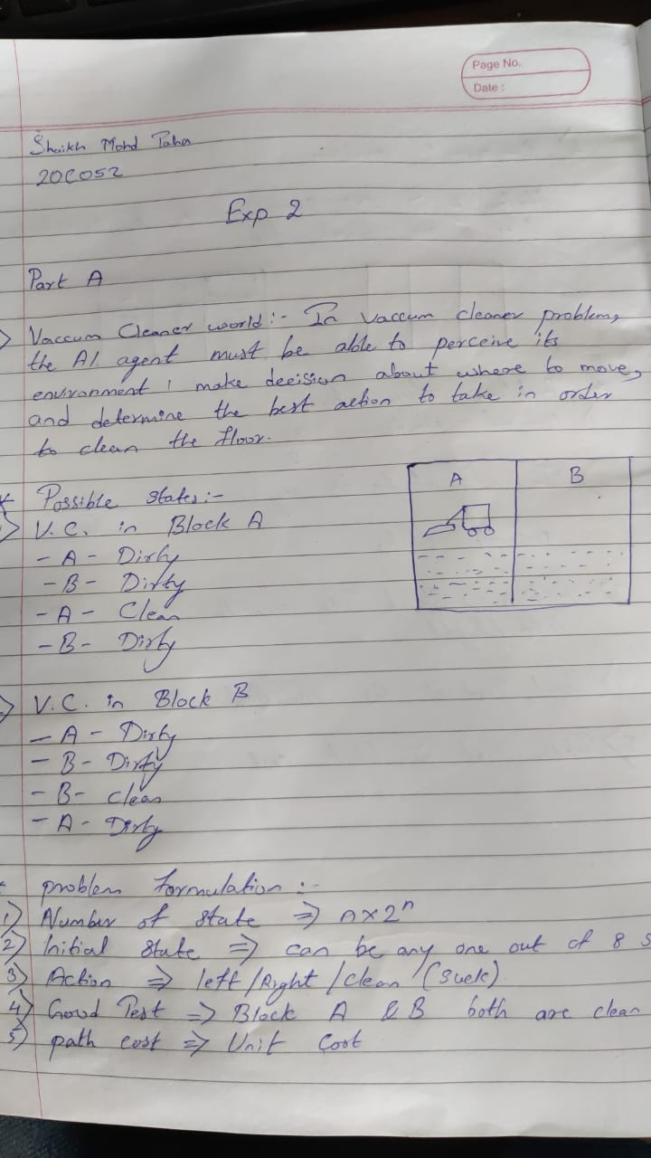

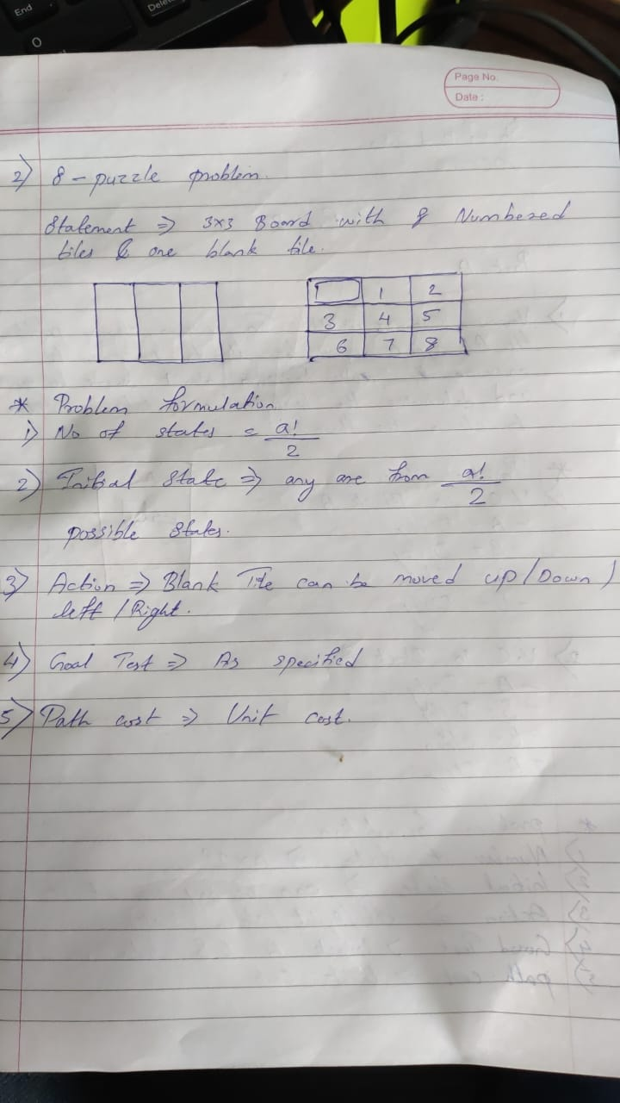

**B]**

| **Agents** | **Performance Measure** | **Environment** | **Actuators** | **Sensors** |
| --- | --- | --- | --- | --- |
| **ATM System** | Dispense cash, process deposits, and perform account inquiries for customers. | Physical location where the ATM machine is located, such as a bank branches | Cash dispenser, Deposit slot, Card Slot and buttons on the ATM machine. | Card reader, keypad, and screen. |
| **Interactive English Tutor** | Assessing a student's English proficiency, provide personalized lesson plans, and track their progress | A computer or mobile device, with internet connection. | Buttons, keyboard | A microphone if the tutor includes speech recognition |
| **Automated Taxi Drivers** | Safely and efficiently navigate to a destination while complying with traffic laws, avoiding accidents, and providing a comfortable and reliable service to passengers. | Road network, including streets, highways and traffic conditions, also people and infrastructures | Steering, acceleration and braking systems | Cameras, LIDAR, radar, GPS, and ultrasonic sensors. |
| **Blood testing System** | Analyze a patient's blood sample, identify any abnormal results, and provide accurate and timely results to the healthcare provider. | A laboratory or a point-of-care setting, such as a doctor's office or hospital. | Needles, test tubes, and analyzers. | Spectrophotometers, Centrifuges, and Microscopes. |
| **E- Commerce System** | Provide customers with a convenient, easy-to-use, and secure platform to browse and purchase products online and also ability to handle inventory management, process transactions, and handle customer service inquiries. | Online, accessed through a web browser or mobile application on a computer or mobile device. | Buttons and links on the website or mobile application that allow customers to browse products, add items to their cart, and complete transactions. | The software that tracks customer browsing and purchase behavior, as well as the security measures that protect sensitive customer information such as payment and personal details |
| **Satellite Image Analysis System** | Ability to accurately and efficiently process and interpret satellite images, identify features and patterns of interest, and provide relevant information to users. | The collection and processing of satellite imagery data. | The software and algorithms used to process and analyze the images, as well as the tools used to display and output the results of the analysis. | The satellites and cameras that capture the imagery, as well as the software and algorithms that interpret the images. |